**1.1)**

WITH top_five_customer (customer_id, first_name, last_name, country, city, total_amount_paid) AS (SELECT

A.customer_id As customer_id,

A.first_name AS first_name,

A.last_name AS last_name,

D.country AS country,

C.city AS city,

SUM(E.amount) AS total_amount_paid

FROM customer A

INNER JOIN address B ON A.address_id = B.address_id

INNER JOIN city C ON B.city_id = C.city_id

INNER JOIN country D ON C.country_id = D.country_id

INNER JOIN payment E ON A.customer_id = E.customer_id

WHERE city IN ('Aurora', 'Tokat', 'Tarsus', 'Altixco', 'Emeishan', 'Pontainak', 'Shimoga', 'Aparaceida de Goiania', 'Zalantun', 'Taguig')

GROUP BY

A.customer_id,

D.country,

C.city

ORDER BY total_amount_paid DESC

LIMIT 5)

SELECT AVG(total_amount_paid) AS average FROM top_five_customer;

**Output**:



**1.2)**

WITH top_five_customer (customer_id, total_amount_paid) AS (

SELECT

A.customer_id as customer_id,

SUM(E.amount) as total_amount_paid

FROM customer A

INNER JOIN address B ON A.address_id = B.address_id

INNER JOIN city C ON B.city_id = C.city_id

INNER JOIN country D ON C.country_id = D.country_id

INNER JOIN payment E ON A.customer_id = E.customer_id

WHERE city IN ('Aurora', 'Tokat', 'Tarsus', 'Altixco', 'Emeishan', 'Pontainak', 'Shimoga', 'Aparaceida de Goiania', 'Zalantun', 'Taguig')

GROUP BY

A.customer_id,

D.country,

C.city

ORDER BY total_amount_paid DESC

LIMIT 5)

SELECT country.country, COUNT(customer) AS all_customer_count, COUNT(top_five_customer) AS top_customer_count

FROM customer

INNER JOIN address

ON customer.address_id = address.address_id

INNER JOIN city

ON address.city_id = city.city_id

INNER JOIN country

ON country.country_id = city.country_id

LEFT JOIN top_five_customer

ON customer.customer_id = top_five_customer.customer_id

GROUP BY country.country

ORDER BY top_customer_count DESC, country.country;

**Output**:

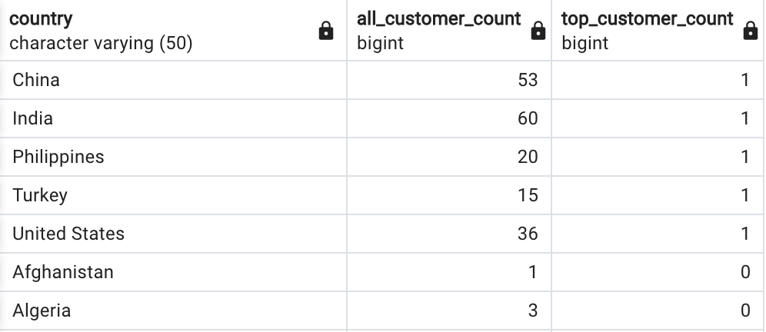

……. every single country

Comment:

The rewriting of the queries was simple. I just grabbed the inner query and implemented it as the CTE's foundation. I then replaced the inner query for the CTE name. My code was therefore more readable and better organized.

**2)**

Costs

1.1: average: cost 44-53 msc

2.1: average: cost 46-64 msc

1.2: average: cost 43-50 msc

2.2: average: cost 46-72 msc

Comment:

The fact that the computer needs additional time because we generate a table that requires storage space does not really surprise me. But with such short queries, the difference is not all that significant. It will only get worse, in my opinion, if you use larger queries. I believe it is wise to use CTEs first before integrating them into an inner/outer query. Through this method, we may benefit from the speedier query while simultaneously using the enhanced readability.

**3)**

I haven't had any difficulties because everything in the task article was quite clear.